**TABLE OF CONTENT**

|  |  |
| --- | --- |
| **CONTENTS** | **PAGE#** |
| Title | 2 |
| Abstract | 2 |
| Objectives | 2 |
| Breakdown of project | 3 |
| Description | 3 |
| Result outcome/Explanation | 4 |
| conclusion | 6 |

----------------------------------------------------------------------------------------------------

**TITLE:**

*STAY HEALTHY (DIET_PLAN)*

**ABSTRACT:**

Nowadays maintaining diet, a healthy routine and a proper fitness track is quite difficult in this busy life, that’s why we have created an app known as ***Stay Healthy*** that would check your daily fitness track and would update you with new features and would keep a check and balance to your diet within seconds.

**OBJECTIVES:**

* The main objective of our app is to give people a healthy lifestyle.
* To assign them diet plan according to their requirements.
* To track nutritional and to manage diet for a better lifestyle.
* Promises a good physical condition.

**BREAKDOWN OF PROJECT:**

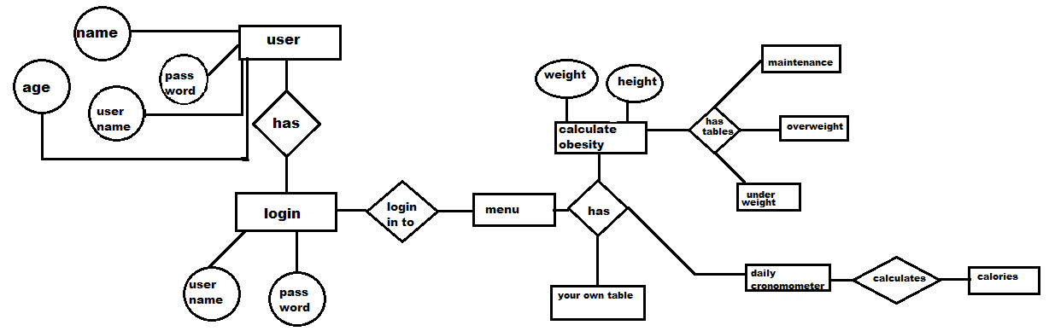

**DESCRIPTION:**

**Backend:**

We have used the database server known as **sql server** in our project as our backend. we have created tables like: -

1. **Registration table:** that would store all the user information like name, age, email and password etc in our database.
2. **Login table:** that will contain the email and password of a user so that they can easily sign up to their accounts.
3. **Maintenance table:** it would contain the 5 days’ plan for those user who have average obesity.
4. **Overweight table:** it would contain the 5 days’ plan for those user who have obesity.
5. **Underweight table:** it would contain the 5 days’ plan for those user who are underweight.

We have also worked on the frontend of the app which is described in detail below.

**RESULT OUTCOME/EXPLANATION:**

The following is the explanation of our project.

* ***The login page***

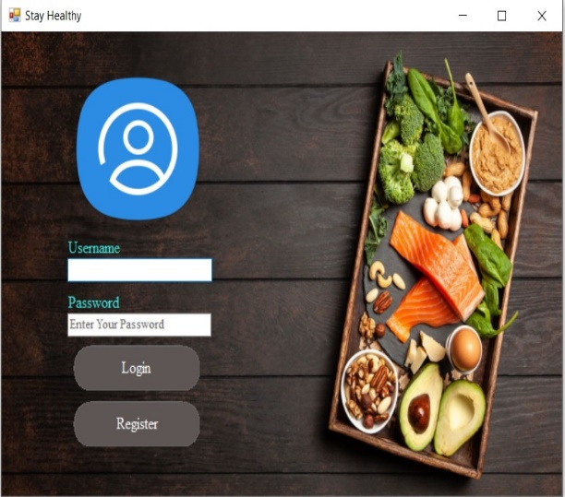

The login page is the first tab that appears on our app. It has two buttons **login** and **registration**. **Login** for those users who already have an account on this app (email or password stored in our database). **Registration** for those who doesn’t have an account in this app (their data will be stored in the database later on).

* ***Registration tab***

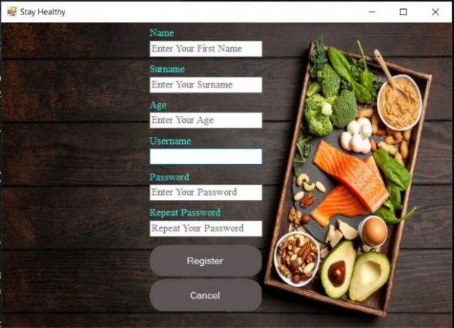

if the user clicks on the register button he would be automatically shifted to this tab

where he would register himself into this app (his information will be saved in the

database).

By clicking on register his information will be saved. Then he would go back to the login tab and sign in.

* ***Menu Tab***

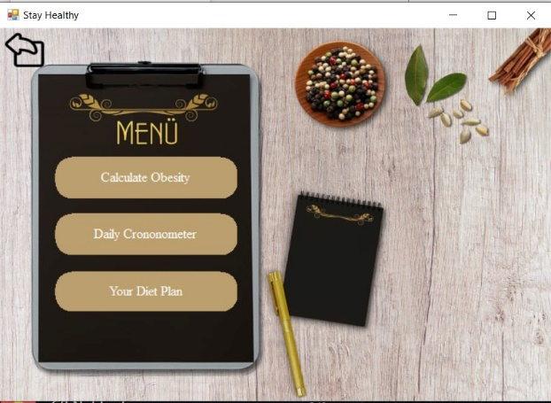

When the user will sign in he would be shifted to the menu tab where, he would be given three option to choose **calculate obesity, daily chronometer, your diet plan.** The function of calculate obesity is that it calculates obesity by putting weight and age, and it would assign table according to your obesity if you are obese than the table of **overweight** will be shown, if you are maintained than **maintenance table** will be shown and if you are under weight than **underweight** table will be shown (each with 5 days of diet plan).

* ***Obesity Calculator***

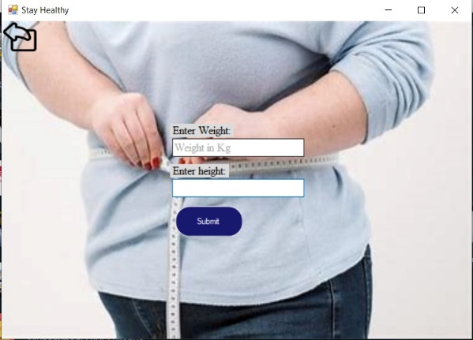

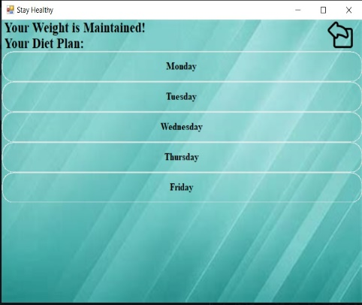

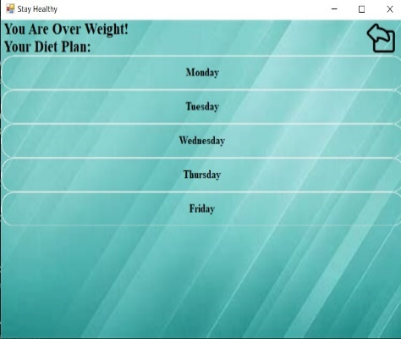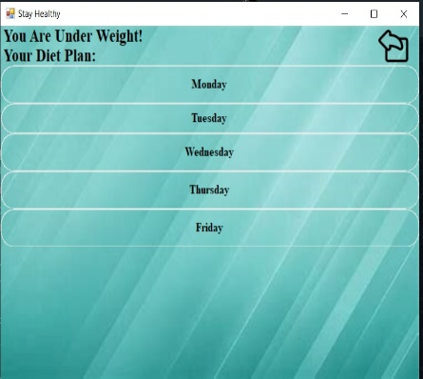**the following three tables are: -**

when user click on the day of which user want to follow the diet plan off, the diet plan of that respective day will be shown so that user can follow that diet plan and live a healthy life.

* ***The Daily Chronometer***

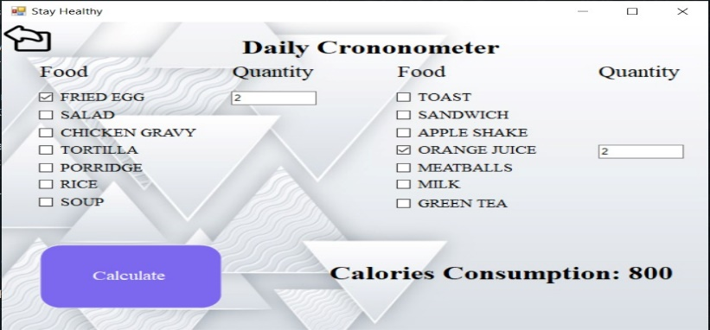It checks the total calories a person has consumed according to his diet according to the quantity.

* ***Your Diet Plan***

It let you see your diet plan that was given by the obesity calculator, so that you can follow the diet plan and stay a healthy life.

**CONCLUSION:**

With the help of sql server and visual studio we were successful in creating our diet plan app “Stay Healthy”. Our objectives for maintaining a healthy lifestyle for people was achieved and we were successful in creating an app which contain all the requirements for people who are conscious about their health problems and their maintenance of weight.

-----------------------------------------------------------------------------------------------------------------